MET CS 555 Assignment 2
Joseph Rissman
10/05/2024
- Summarize the data by whether children participated in the meal preparation or not.
 | Minimum | 1st Quartile | Median | 3rd Quartile | Max | Mean | Standard Deviation
Participant | 211.0 | 298.4 | 424.9 | 456.3 | 635.2 | 410.1 | 121.5
Non-participant | 139.7 | 296.4 | 374.7 | 445.6 | 688.8 | 374.1 | 133.1

Also include a graphical presentation that shows the distribution of calories for participants vs. non-participants.
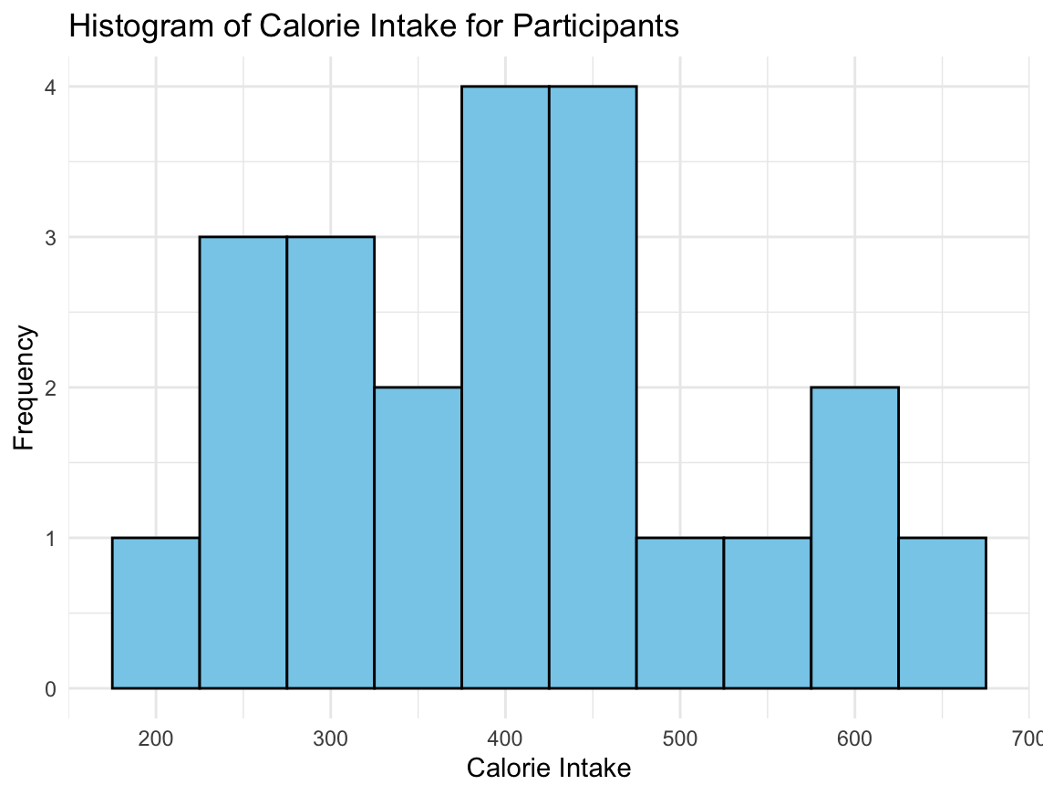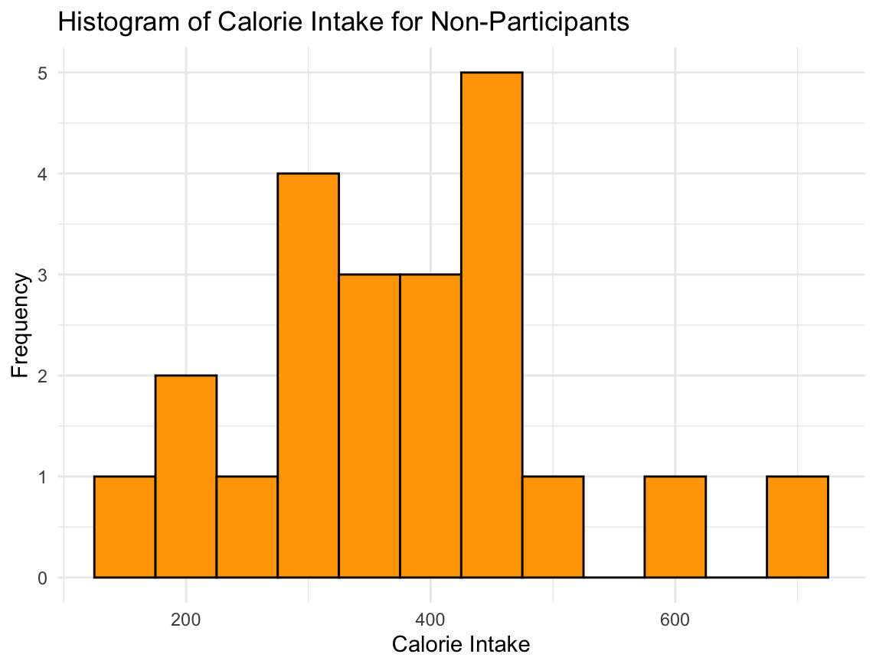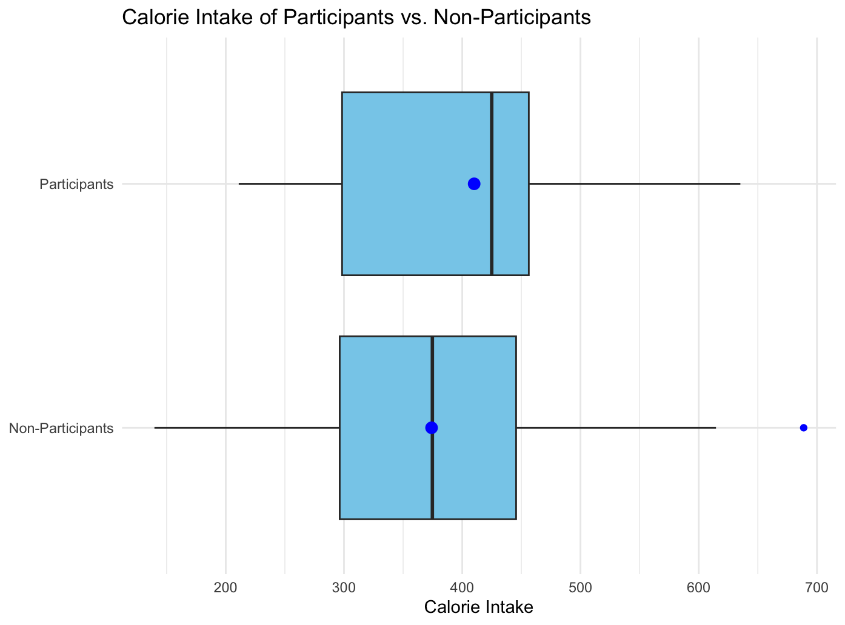
Describe the shape of each distribution and comment on the similarity (or lack thereof) between the distributions in each group.
Using the SOCS method for both groups:
 | Participant | Non-participant
Shape | Unimodal, balanced | Unimodal, right skewed
Outliers | None | One or two outliers on the higher end
Center | Mean and median are 400-450 | Mean and median are equal (unusual for skewed data) at 374
Spread | IQR ~ 160  SD ~120 | IQR ~ 150  SD ~ 130
Both groups have a similar distribution that is approximately normal.

- Does the mean calorie consumption for those who participated in the meal preparation differ from 425? Formally test at the alpha = 0.05 level using the 5 steps outlined in the module.
  - Set up the hypotheses and select the alpha level
H₀ : μ = 425
H_{a} : μ ≠ 425
α = 0.05
The null hypothesis is that the mean calorie consumption for participants is 425.
The alternative hypothesis is that the mean calorie consumption for participants is different than 425 (two-tailed).
The alpha level is stated to be 0.05.
  - Select the appropriate test statistic
The size of the sample is 25, so it’s appropriate to use the t-test. The degrees of freedom are 24.
  - State the decision rule
The t-statistic value for df = 24 and two-tailed alpha = 0.05 is t = 2.064.
Decision Rule: Reject H₀ if |t| ≥ 2.064.
Otherwise, do not reject H₀.
  - Compute the test statistic and the associated p-value
$$t=\frac{\overline{x}-μ}{\frac{s}{\sqrt{n}}}=\frac{410.1-425}{\frac{121.5}{\sqrt{25}}}=\frac{-14.9}{24.3}=-0.613$$
The p-value is between 0.50 and 1 when t = -0.613 and df = 24.
  - State your conclusion
Fail to reject H₀ because |t| = 0.613 is less than 2.064.
We do not have sufficient evidence at the α = 0.05 level that the mean calorie consumption of participants is different than 425.
- Calculate a 90% confidence interval for the mean calorie intake for participants in the meal preparation. Interpret the confidence interval.
The confidence interval can be calculated using the formula
$$\overline{x}±t_{0.9, 24}×\frac{s}{\sqrt{n}}$$
Where $t_{0.9, 24}$ is the test statistic at 90% confidence for 24 degrees of freedom.
$$\overline{x}±t_{0.9, 24}×\frac{s}{\sqrt{n}}=410.1±1.711×\frac{121.5}{\sqrt{25}}=410.1±41.6$$
We are 90% confident that the true mean calorie consumption of participants in meal preparation was between 368.5 and 451.7.
- Formally test whether or not participants consumed more calories than non-participants at the alpha = 0.05 level using the 5 steps outlined in the module.
  - Set up the hypotheses and select the alpha level
H₀ : μ_{p} - μ_{np} = 0
H_{a} : μ_{p} - μ_{np} ≠ 0
α = 0.05
The null hypothesis is that the mean calorie consumption for participants and non-participants is the same.
The alternative hypothesis is that the mean calorie consumption for participants is different than non-participants.
The alpha level is stated to be 0.05.
  - Select the appropriate test statistic
The size of the samples are 25 and 22, so it’s appropriate to use the t-test. The degrees of freedom are difficult to calculate manually, so the smaller of the samples is chosen. Degrees of freedom is 21.
  - State the decision rule
The t-statistic value for df = 21 and two-tailed alpha = 0.05 is t = 2.080.
Decision Rule: Reject H₀ if |t| ≥ 2.080.
Otherwise, do not reject H₀.
  - Compute the test statistic and the associated p-value
$$t=\frac{{\overline{x}}_{p}-{\overline{x}}_{np}}{\sqrt{\frac{s_{p}^{2}}{n_{p}}+\frac{s_{np}^{2}}{n_{np}}}}=\frac{410.1-374.1}{\sqrt{\frac{{121.5}^{2}}{25}+\frac{{133.1}^{2}}{22}}}=\frac{36}{\sqrt{590.49+805.255}}=\frac{36}{37.36}=0.96$$
The p-value is between 0.30 and 0.40 when t = 0.96 and df = 21.
  - State your conclusion
Fail to reject H₀ because |t| = 0.96 is less than 2.080.
We do not have sufficient evidence at the α = 0.05 level that the mean calorie consumption of participants is different than non-participants.
- Are the assumptions of the test used in (4) met? How do you know?
The assumptions for using a two-sample t-test are as follows:
  - Independence
  - Same Measurement
  - Normal Distribution
For this data set, we know that the participants and non-participants are different groups which are assumed to be independent, so the first condition is met. The calorie intake per meal was used as the measurement for both groups, so the second condition is met. The data exploration in question 1 of this assignment as well as Q-Q plots show that the values of both groups are roughly normally distributed, so the third condition is met.
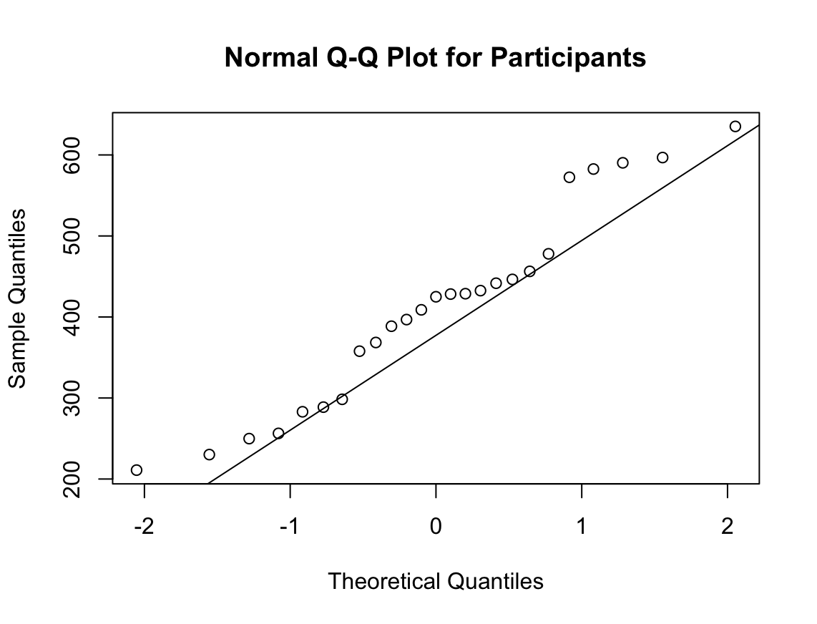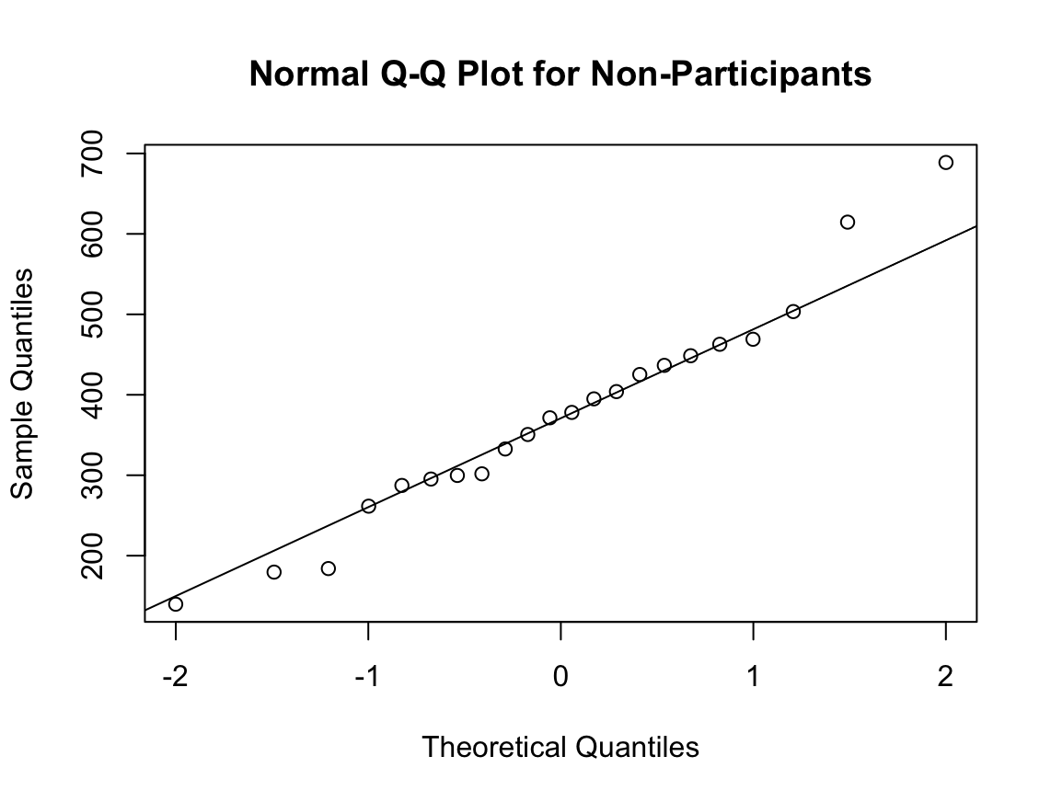

R code for Assignment 2
# CS555 Homework Assignment 2
# Load necessary libraries ------------------------------------------------
library(readxl)
library(dplyr)
library(tidyr)
library(ggplot2)

# Import and clean data ---------------------------------------------------
# Read experiment data from Excel file
data <- read_excel("Homework 2/Homework 2 Data.xlsx", col_names = TRUE)
df <- data_frame(data) %>%
rename(participants = 'Calorie Intake for participants',
non_participants = 'Calorie intake for non-participants')

# Problem 1 ---------------------------------------------------------------
# Calculate summary statistics of data for each group
summary(df)
sd(df$participants)
sd(df$non_participants, na.rm = TRUE)

# Create histograms for each group to visualize data
ggplot(df, aes(x = participants)) +
geom_histogram(binwidth = 50, fill = "skyblue", color = "black") +
labs(title = "Histogram of Calorie Intake for Participants",
x = "Calorie Intake",
y = "Frequency") +
theme_minimal()

ggplot(df, aes(x = non_participants)) +
geom_histogram(binwidth = 50, fill = "orange", color = "black") +
labs(title = "Histogram of Calorie Intake for Non-Participants",
x = "Calorie Intake",
y = "Frequency") +
theme_minimal()

# Pivot the data to create a box plot
df_pivot <- df %>%
pivot_longer(cols = c(participants, non_participants),
names_to = "group",
values_to = "value",
values_drop_na = FALSE)
# Create box plot to visualize data from each group
ggplot(df_pivot, aes(x = group, y = value)) +
geom_boxplot(fill = "skyblue", outlier.color = "blue") +
labs(title = "Calorie Intake of Participants vs. Non-Participants",
x = NULL,
y = "Calorie Intake") +
coord_flip() +
scale_x_discrete(labels = c('Non-Participants','Participants')) +
stat_summary(fun = "mean", geom = "point", size = 3, color = "blue") +
theme_minimal()

# Problem 2 ---------------------------------------------------------------

# Calculate t.test that participants have mean calorie consumption different than 425.
t.test(df$participants, mu = 425, alternative = "two.sided", conf.level = 0.95)

# Problem 3 ---------------------------------------------------------------

# Calculate 90% confidence interval using t.test method
t.test(df$participants, conf.level = 0.9)$conf.int

# Problem 4 ---------------------------------------------------------------

# Calculate two-sample t.test that participants have difference from non-participants.
t.test(x = df$participants, y = df$non_participants, alternative = "two.sided", conf.level = 0.95)

# Problem 5 ---------------------------------------------------------------

# Create quantile-quantile plot for both groups to assess normality
qqnorm(df$participants, main = "Normal Q-Q Plot for Participants")
qqline(df$participants)
qqnorm(df$non_participants, main = "Normal Q-Q Plot for Non-Participants")
qqline(df$non_participants)

